LAB 1 ARYAMAN MISHRA 19BCE1027
1. Annual sales (in lakh of Rs.) of a pharmaceutical firm for six years(2013-2018)given below:
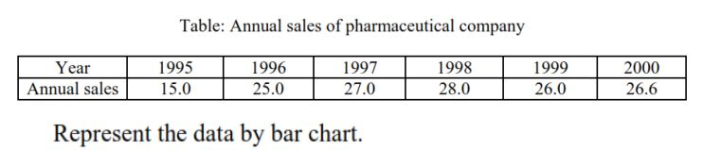
CODE:
year=c(1995,1996,1997,1998,1999,2000)
annualsales=c(15.0,25.0,27.0,28.0,26.0,26.6)
tabinfo=data.frame(annualsales,year)
tab=table(tabinfo$annualsales,tabinfo$year)
barplot(tabinfo$annualsales,tabinfo$year,names.arg=c("1995","1996","1997","1998","1999","2000"),xlim=c(1,10000),ylim=c(1,70))
legend("topright",legend=rownames(tab),fill=c("blue","red"),bty="n")

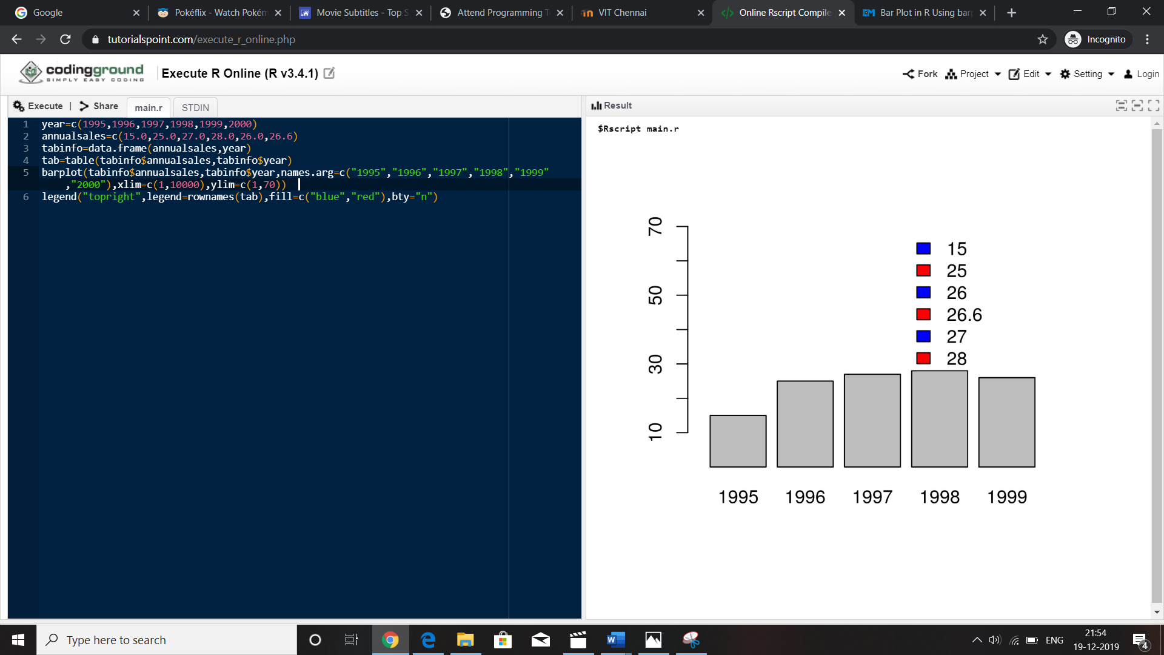
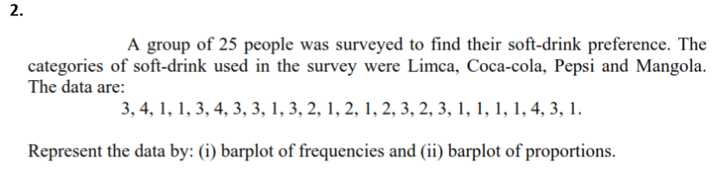
CODE:
x=c(3,4,1,1,3,4,3,3,1,3,2,1,2,1,2,3,2,3,1,1,1,1,4,3,1)
table1=table(x)
barplot(table1)
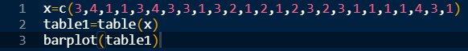
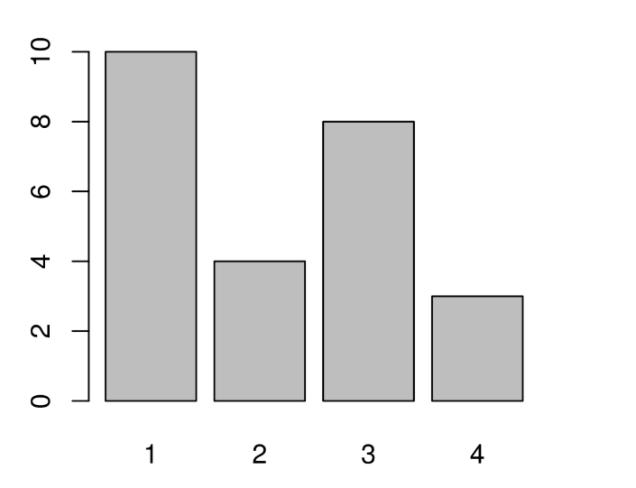
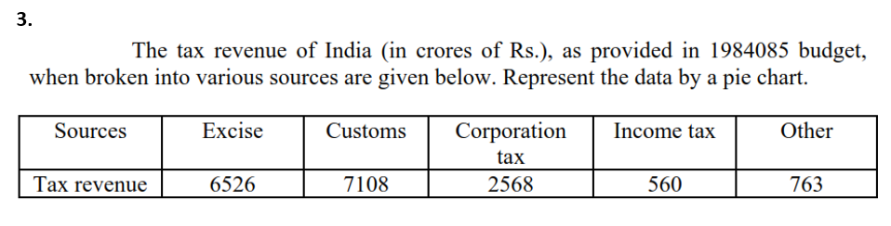

CODE:
tax=c(6526,7108,2568,560,763)
s=c("Excise","Customs","Corporation Tax","Income Tax","Other")
pie(tax,labels=s)
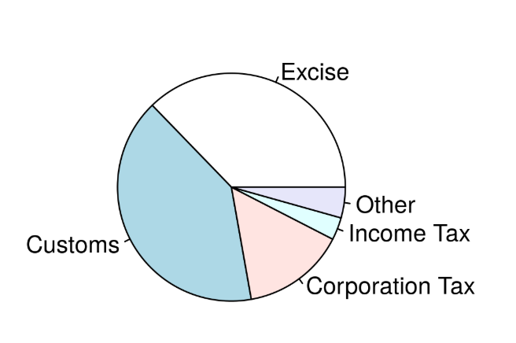
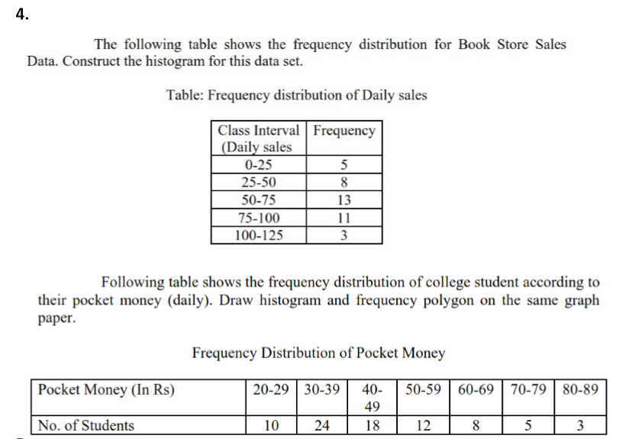
CODE:
f=c(5,8,13,11,3)
ci=c(0,25,50,75,100)
plot(ci,f,xlab="Daily Sales",ylab="frequency",type="h",col="blue")
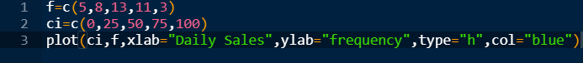
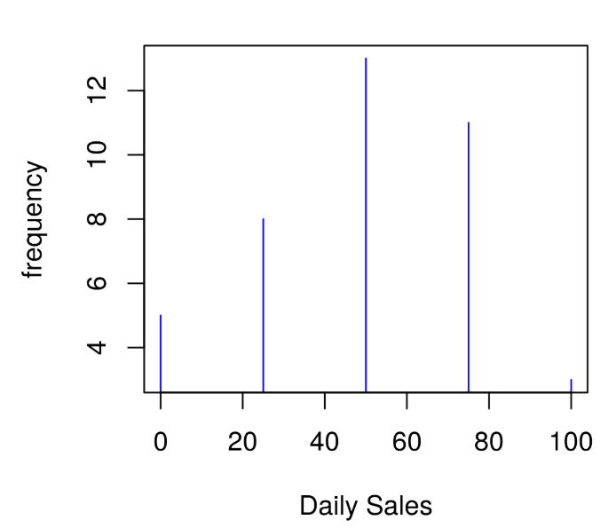
ns=c(10,24,18,12,8,5,3)
po=c(30,40,50,60,70,80,90)
plot(po,ns,xlab="Pocket money",ylab="No. of students",type="h",col="blue")
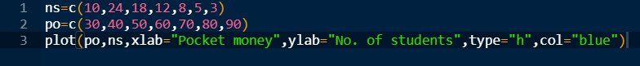
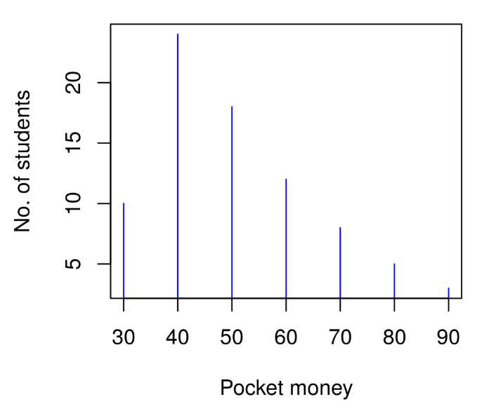
x=c(3,4,1,1,3,4,3,3,1,3,2,1,2,1,2,3,2,3,1,1,1,1,4,3,1)
table1=table(x)
barplot(table1)
barplot(prop.table(table(x),margin=1), beside=TRUE)
ns=c(10,24,18,12,8,5,3)
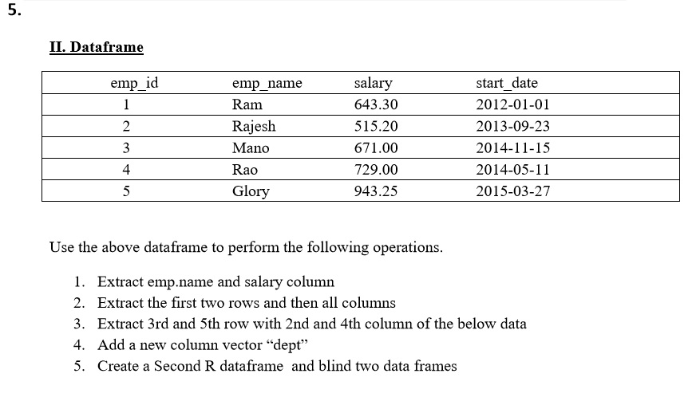
CODE:
emp_id=c(1,2,3,4,5)
emp_name=c(“Ram”,”Rajesh”,”Mano”,”Rao”,”Glory”)
salary=c(643.30,515.20,671.00,729.00,943.25)
start_date=c(“2012-01-01”,”2013-09-23”,”2014-11-15”,”2014-05-11”,”2015-03-27”)
df=data.frame(emp_id,emp_name,salary,salary_date)
df
“ “
“ “
df[1:2,2:3]
“ “
“ “
df[1:2,1:4]
“ “
“ “
df[c(3,5),c(2,4)]
dept=c(“R & D”,”HR”,”Sales”,”Export”,”Administration”)
df=cbind(df,dept)
“ “
“ “
df
state=c(“U.P”,”Tamil Nadu”,”Kerela”,”Karnataka”,”Maharashtra”)
experience=c(4,2,2,3,1)
df1=data.frame(state,experience)
df=cbind(df,df1)
“ ”
“ “
df
